Name : Tatiana Moteu Ngoli
Batch code : app.py
Submission data : 28th September 2022
Submitted to : Data Glacier

- Dataset : Iris data

- The model : the code can be find in the file model.py and the model has been save under the name model.pkl

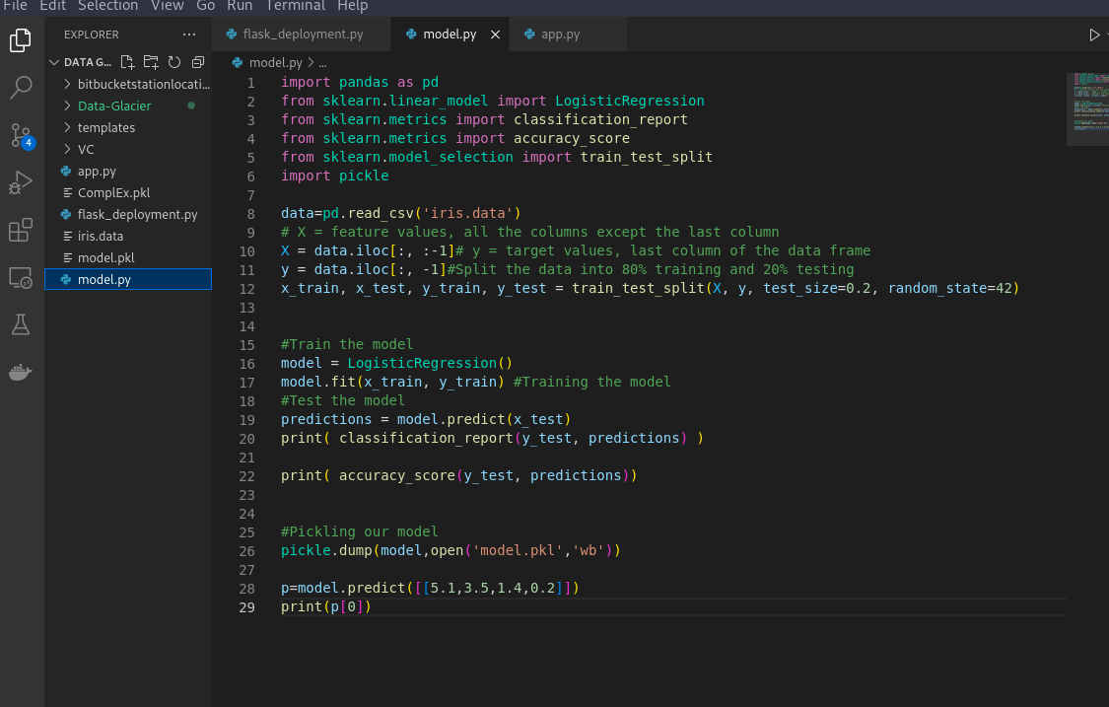
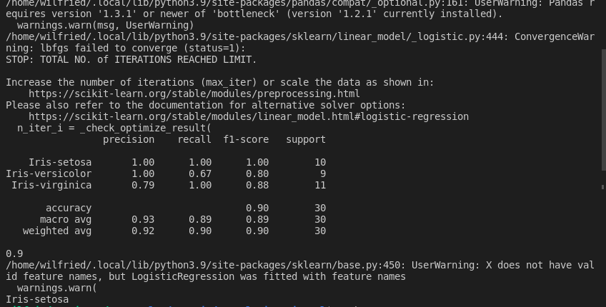

- Deployment on Flask (web app) : We first loaded our model using pickle and then we created our app and we wrote a function to do the prediction and print it on our webpage. The code can found in the file app.py as showed in the following pictures

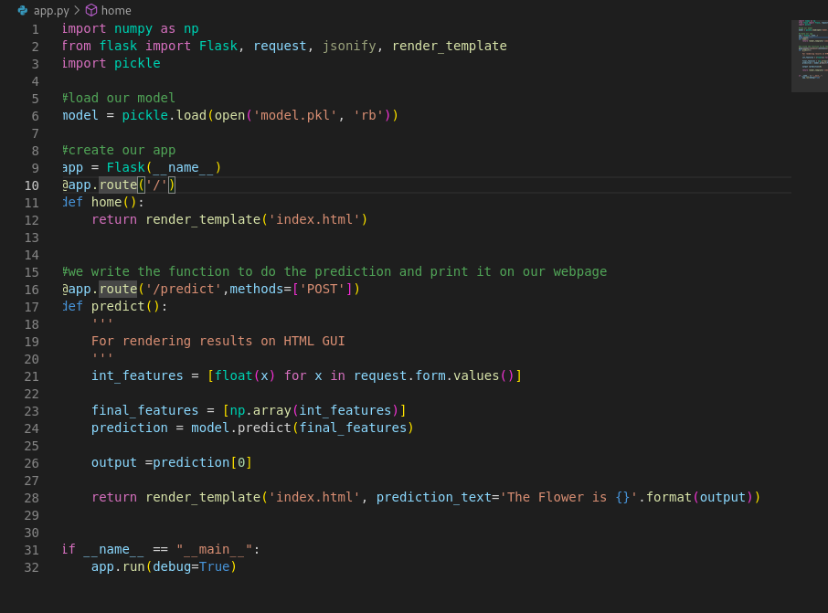
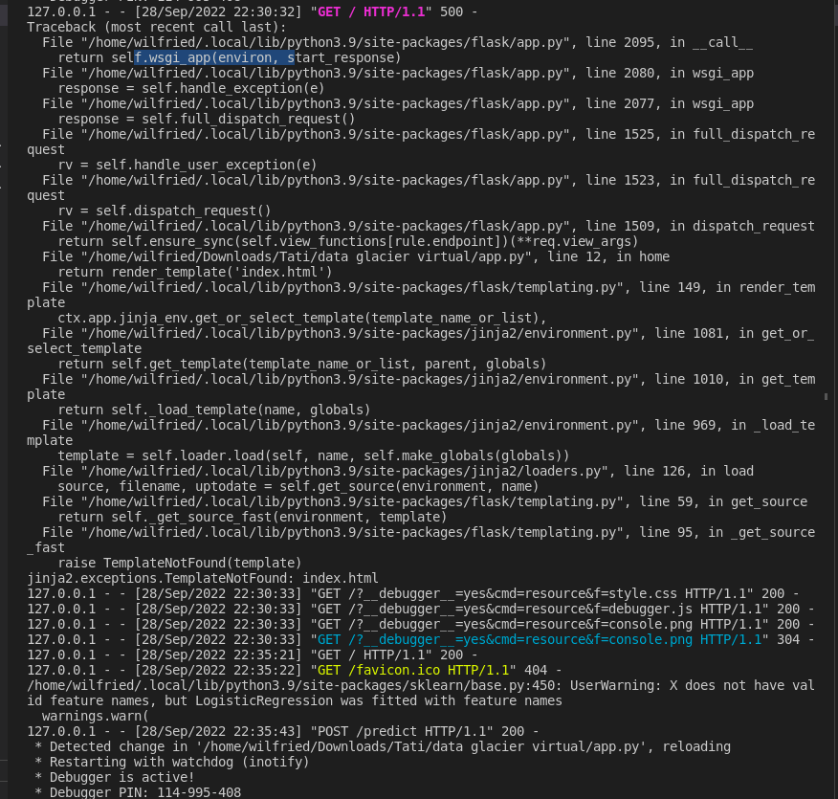

The deployment on the web page is showed in the image below:
